#include <iostream>

using namespace std;

class grade

{

public:

grade()

{

times = 2;

cout << "grade construction1 called" << endl;

}

grade(int times1)

{

times1 = times;

cout << "grade construction2 called" << endl;

}

~grade()

{

cout << "grade ddestruction called" << endl;

}

void inputgrade()

{

for (i = 0; i < times; i++)

{

cin << name << endl;

cin << grade[i][1] << endl;

cout << "请输入科目a成绩" << endl;

cin << grade[i][2]<<endl;

cout << "请输入科目b成绩" << endl;

cin << grade[i][3] << endl;

cout << "请输入科目c成绩" << endl;

}

void showgrade()

{

cout << "成绩" << endl;

cout << "(" << grade[i][1] << "," << grade[i][2] << "," << grade[i][3] << ")" << endl;

}

void showavegrade()

{

float avea = 0;

float aveb = 0;

float avec = 0;

for (i = 0; i < times; i++)

{

avea = avea + grade[i][1];

aveb = aevb + grade[i][2];

avec = avec + grade[i][3];

}

avea = avea / times;

aveb = aveb / times;

avec = avec / times;

cout << "平均成绩" << endl;

cout << "(" << avea << "," << aveb << "," << avec << ")" << endl;

}

private:

int times;

float grade[100][100];

char name;

};

int main()

{

std::cout << "Hello World!\n";

}

代码

结果

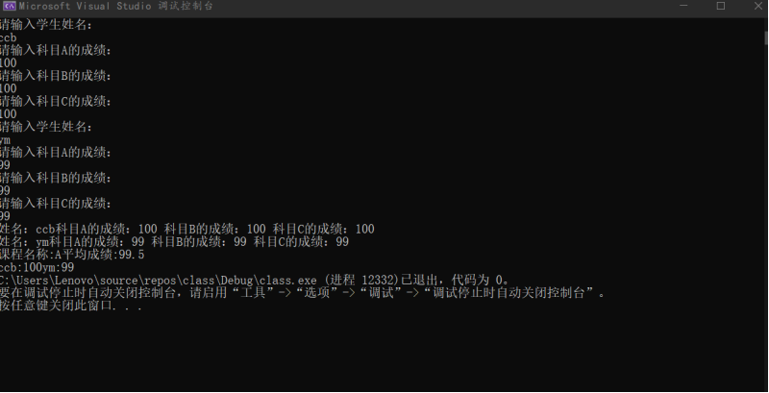

感悟：通过这次实验，学会了在实际操作中使用类和对象，并且掌握构造函数和析构函数的使用，让c++程序成功的运行，而且也通过ppt上的课件学会如何用数组来表示坐标

Copyright ©2021-2099 luanxiang wang.All rights reserved